Appendix 1: Validations since March.2017

Error Number | Error Message | Reject Record | Description | Remediation
320 | Invalid Type of Transplant | Y | Type of transplant: must be one of the values Auto, Allo R, Allo U, Haplo. Ignore if Photopheresis_Treatments is not null | Select type of tranplant
331 | Date must be after the initial diagnosis (for Allo-R) or after HLA typing (for Allo-U and HAPLO) and before transplant date | Y | If type of transplant is Allo-R then  Date of match found must be after the date of initial diagnosis and before the date of transplant.  If type of transplant is Allo-U or HAPLO then  Date of match found must be after the date of HLA typing and before the date of transplant.  Ignore Validation if Null  Ignore validation if date of HLA typing is null  Ignore if Photopheresis_Treatments is not null | Enter a date that is after the initial diagnosis for Allo-R or after HLA typing for Allo-U and HAPLo and before transplant date
338 | Invalid date of first induction - Type of transplant must be Allo-R or Allo-U or Haplo | Y | Date of First Induction : If this date is present, the type of transplant must be one of Allo-R or Allo-U or Haplo.  Ignore validation if null  Ignore validation if Photopheresis_Treatments is not null | Select Allo-R or Allo-U or Haplo as the type of tranplant
339 | Invalid date of first re-induction - Type of transplant must be Allo-R or Allo-U or Haplo | Y | Date of First Re-induction: If this date is present, the type of transplant must be one of Allo-R or Allo-U or Haplo.  Ignore validation if null  Ignore validation if Photopheresis_Treatments is not null | Select Allo-R or Allo-U or Haplo as the type of tranplant
609 | When Type_Transplant is Allo-R or Allo-U or Haplo, and Canceled_Flag is 'No', Ready_to_Transplant_Date must have a value | Y | Type_Transplant is (Allo-R or Allo-U or Haplo) and Canceled_Flag is 'No' and (and Post_Transplant_Receiving_Centre_Submission is not ‘Yes’) and Ready_to_Transplant_Date is Null | Enter a ready to transplant date
610 | Ready_to_Transplant_Date must be before Transplant Date | Y | Ready_to_Transplant_Date is not Null and Date_Transplant is not Null and Ready_to_Transplant_Date > Date_Transplant | Enter a ready to transplant date that is before the transplant date
619 | The dose value must be within the allowed range for this drug | Y | If does value is greater than the specified upper range for Carmustine (700mg) and/or thiotepa (2000mg), display error msg | Enter a dose that is lower than the upper does limit for Carmustine and thiotepa

Appendix 2: Facility Numbers
# | Program Title | Submitting Hospital | Facility Number
1 | Stem Cell Transplant | Kingston General Hospital | 693
 |  | Mt. Sinai Hospital | 842
 |  | Grand River Hospital Corp | 930
 |  | Windsor Regional Hospital | 933
 |  | Thunder Bay Regional Health Sciences Centre | 935
 |  | London Health Sciences | 936
 |  | Hamilton Health Sciences Corporation | 942
 |  | University Health Network | 947
 |  | Lakeridge Health | 952
 |  | Sunnybrook Health Sciences Centre | 953
 |  | The Ottawa Hospital | 958
 |  | Health Sciences North | 959
 |  | Niagara Health | 962
 |  | Trillium Health Partners | 975

Appendix 3: Valid 2-digits Postal Codes
(Source: Cancer Care Ontario's Data Book - 2012-2013, Appendix B - Province and State codes, at link https://www.cancercare.on.ca/ext/databook/db1213/databook.htm).

The table below provides list of valid 2 digit postal codes for province and State codes.
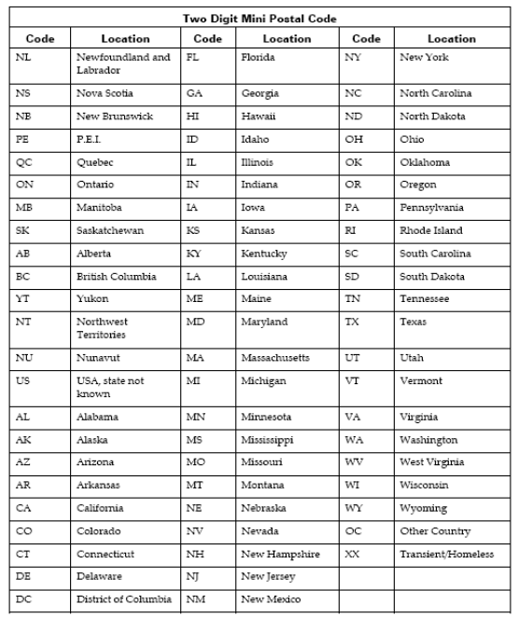

Appendix 4: SCT Disease Indication Classification
(Source: Cancer Care Ontario's Data Book - 2012-2013, Appendix 12.1 - SCT Disease Indication Classification, at link https://www.cancercare.on.ca/ext/databook/db1213/databook.htm).

Name | Description
AML /APL | Acute Myeloid Leukemia (including Acute promyelocytic leukemia (APL))
ALL | Acute Lymphoblastic Leukemia (including lymphoblastic lymphoma)
AcuteLeukemiaOther | Acute leukemia other
CML | Chronic Myeloid Leukemia
CLL | Chronic Lymphocytic Leukemia
MDS/MPD | Myelodysplastic / Myeloproliferative Disease
MM | Multiple Myeloma
Amyloidosis | Amyloidosis
NHL | Non-Hodgkin's Lymphoma
HL | Hodgkin's Lymphoma
SAA | Severe aplastic anemia
Solid-Sarcoma | Solid tumours - Sarcoma
Solid-GermCell | Solid tumours - Germ cell tumours
Solid-Other | Solid tumours - Other
Other | Transplant indication not listed above

Appendix 5: MOHLTC Master Numbering System
The Master Numbering System has been developed for the purpose of bringing together all Health Facilities and Programs under one system of identification. The list is a composite of health and health related units, facilities, clinics, programs and services. Each such organization has been assigned a unique four digit identifying code.
(For details, please refer Cancer Care Ontario's Data Book - 2012-2013, Appendix A: MOHLTC Master Numbering System, at link https://www.cancercare.on.ca/ext/databook/db1213/documents/Appendix/CCO_Appendix_A_APR_12.pdf).

Appendix 6: Reason Patient Did Not Proceed

- Disease Related
- Donor Unavailability
- Inadequate Stem Cell Yield
- Patient Comorbidity
- Patient Preference
- Treatment Toxicity
- Other

Appendix 3 on databook
Appendix 11 on databook
Appendix 12b on databook
Appendix 13 on databook
Appendix 26 on databook

